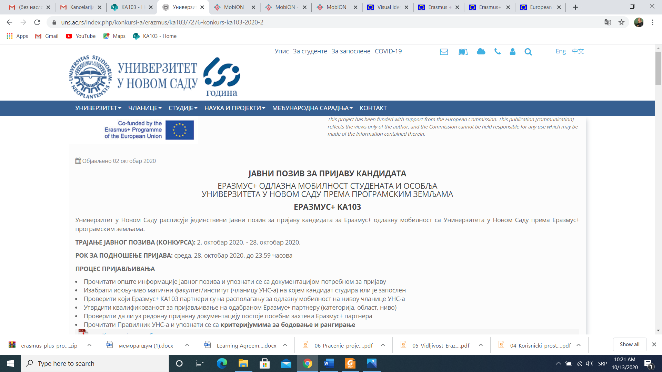

**NOTICE AND CONSENT FOR THE COLLECTION AND PROCESSING OF PERSONAL DATA**

In accordance with line with Constitution Zambia the Bill Rights that guarantees individual freedoms and liberties, we inform you that the University of Lusaka (hereinafter: the operator) collects and processes data about persons from the competition documentation (hereinafter: Data) for the purpose of participating in the Erasmus+ mobility Call and potential implementation of mobility, and for the purpose of selection, statistical data and potential implementation of mobility will collect and process Data that will be stored in an electronic database with the operator, with the prior consent of the Person to whom the Data refers and which will be stored for the period necessary to fulfill the aforementioned purpose.

The person whose Data is collected and processed is entitled to:

1. to revocation of consent. Revocation of consent does not affect the admissibility of processing that was carried out on the basis of consent before the revocation;
2. to access, correction, and deleting of the personal data, i.e. the existence of the right to limit processing, the right to object, as well as the right to data portability;
3. on a complaint to the Commissioner for Information of Public Importance and Personal Data Protection, as well as other rights that belong to the person whose Data is collected in case of unauthorized processing in accordance with the Law on Personal Data Protection;

**STATEMENT OF CONSENT**

I, the undersigned, declare that I have read and understood the Notice and consent for the collection and processing of personal data indicated above, that I have provided my data voluntarily, accurately and completely, that I have been informed that the Data as the operator manages the University of Lusaka (hereinafter: the operator), and that I agree that the operator processes my personal data, specified in the Call documentation, in accordance with the Notification and consent for the collection and processing of personal data .

In Lusaka Zambia , __________ (dd/mm/yyyy)

Consent given by:

__________________________